KOGUTA WATER PROJECT, KENYA

STATUS REPORT

JAN 2016

- Project profile
Project Title: | Koguta Water Project (KOWAP)
Project start date: | September,30th 2014
Project completion date: | April,29th 2015
Project period: | From:September,30th 2014 To:April,29th 2015
Recipient of this report: | Sponsors (donors) from Norway and the project management team
Prepared by: | Tom Omondi-The Project Coordinator

- Status report summary
The Koguta Water Project was designed to enhance access to a safe water supply and contribute to a reduction in water related diseases and other risks involved in search for water. The project activities to achieve these were: drilling and equipping one borehole, and installation of one tank. The upper zone of the village was selected as the location for this project through a participatory community process. In this area, available water sources are temporary and people who live in the upper zone had to walk long distances in search of water.
After drilling of the borehole the following activities were done: installation of water tank, construction of pump house and fencing of the pump site, and the borehole was equipped for use by the Koguta populace and neighborhoods. This was a great gift and it is expected that it will benefit the current and future generation to come sustainably.
- Borehole status
Since its completion, the borehole is in good condition and well protected. Water is flowing, and the project is considered a great success up to this point. Good news! It is my confidence that it will continue being in good condition even in the years to come.
- Borehole management
The project has a team of management who were elected democratically. This is the only area where challenges have been incurred. The management team officials consist of:
- Project Coordinator-Tom Omondi
- Chairman-Gordon Onyango
- Treasurer-Maurine Ogalo
- Secretary-Rose Ogutu
- Operator-Kennedy Ouma and Clarkson Achieng
The challenge was on the daily collection that is, sales made per day. The treasurer and one of the operators were not honest in their daily collection and therefore, I being the coordinator had to call for the board meeting and prove to them that there was no accountability, honesty and transparency in the daily collections. Therefore, since that day, the project coordinator (Tom Omondi) was elected to be the treasurer and he is the one keeping the daily collection and making fuel purchase.
The project has a record book where daily sales are recorded; the project coordinator has a copy and the operator has the same for accountability purposes.
- Project bank account
We have not opened an account for this project because of some formalities that have to be put in place before doing the above. We would like to register this project as Community Based Organization with the relevant government ministry so that we may be issued with the certificate bearing the organization’s name is when we can open an account using the certificate. How is the daily collection kept? I bought a metallic box with a slot on the top where I have been keeping the daily collected money in my house.
When i total from the record book, to this point, the project has collected Ksh 14,085.00 and i hope that this is what is in the metallic box. Were it not for the heavy rain we have been experiencing, the figure above would have been more.
- Achievement/Progress
We have written the constitution for the organization and waiting to gather the required registration fee so that we may send our application. The challenge is on money; members are not contributing the fee and this makes us move at “tortoise” pace!
- Impacts of the Water Project
The following impacts have been realized so far:
- Improved health of the community especially women and children as they are now getting clean and safe water supply,
- Reduced water related infections as the borehole water is safe and clean,
- Improved school attendance for school going children since water is now closer, they can only fetch it after school time; most of the time are devoted to studies, hence improved academic performance.
- Status data records
- Photos
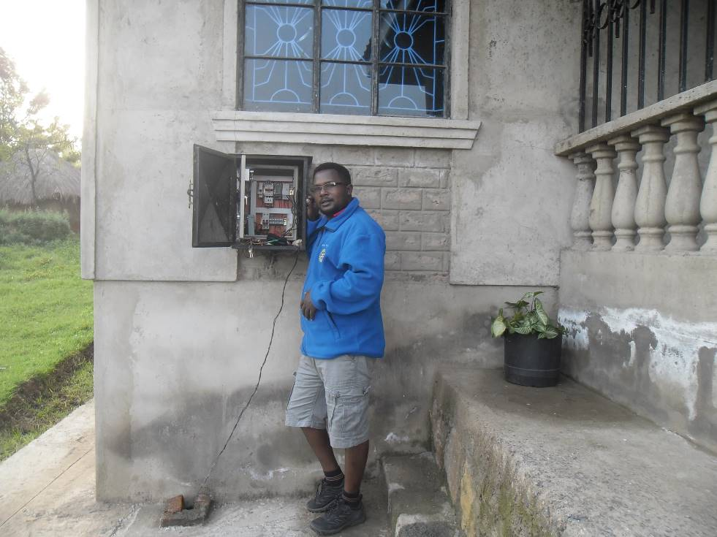
Photo 1: Tom, the project-coordinator shows the first part of the water project; the control panel. It functions properly.
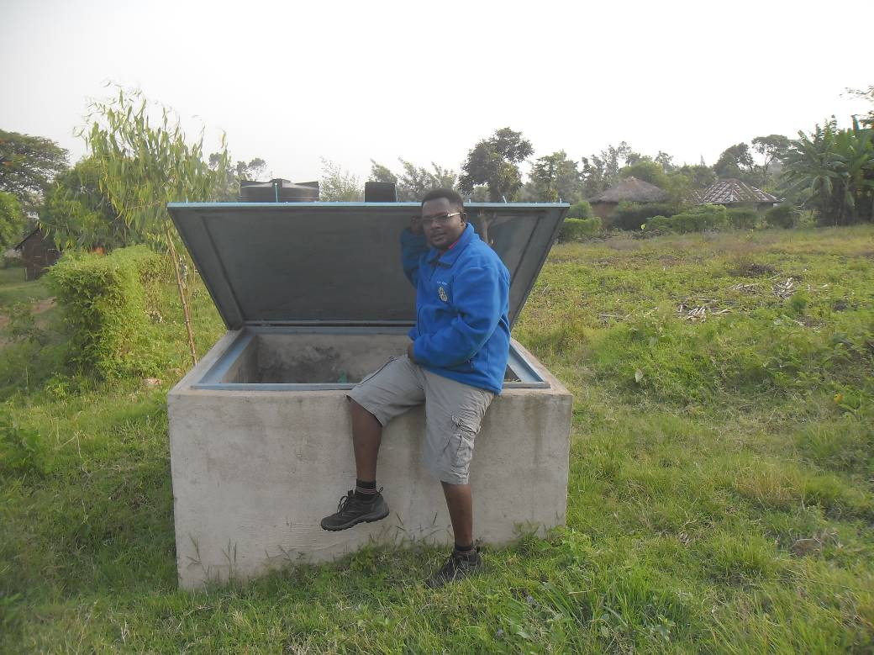
Photo 2: The Borehole point; still in good condition and secured
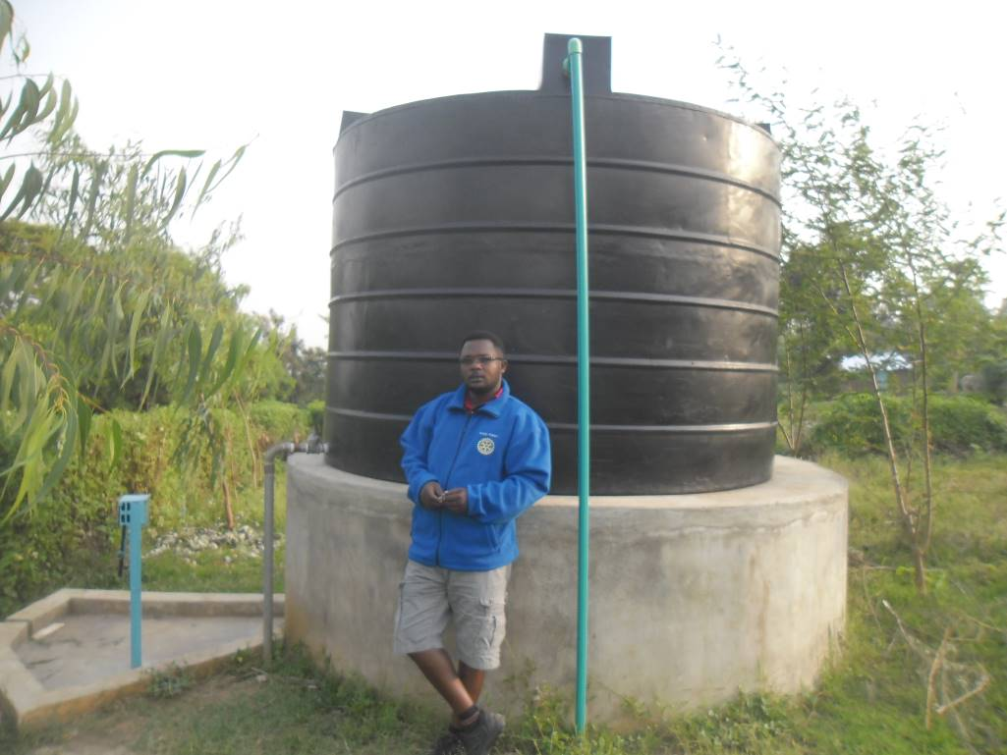
Photo 3: The water tank, in good shape
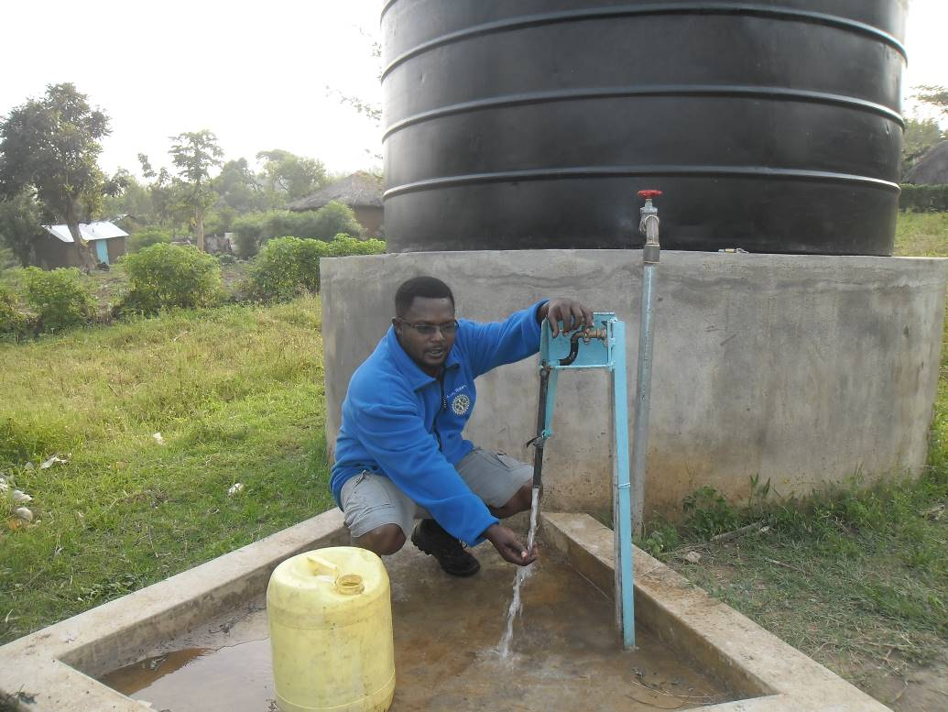
Photo 4: The water is flowing and this is good news!

- Name and email address of person to contact for clarifications

Name: Tom Omondi Okoth
Position: Local Project Coordinator
Cell phone: +254700 175 173
E-mail: tomsomondi@yahoo.com

Prepared and written by Tom Omondi Okoth on 27th January, 2016

