GRACE NURSERY SCHOOL PROGRESS AND UPDATES
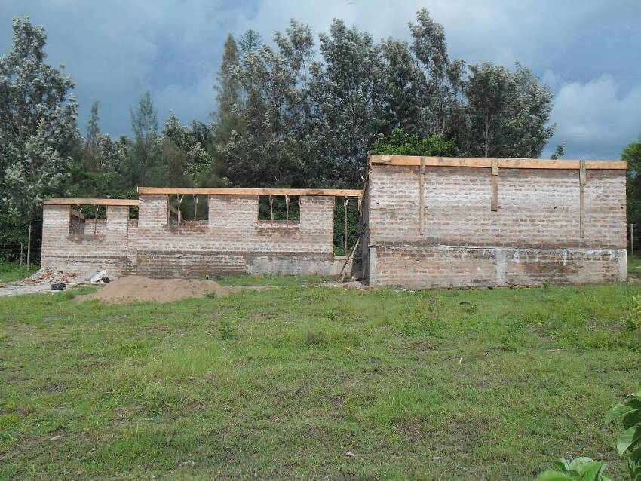 Photo 1: In the photo is the building with timber 9x1 surrounding it. The timber is fixed all round both inner and outer part of the wall to form a box like structure after which the metal Y12 is fixed in-between then the concrete is poured inside the wooden box.

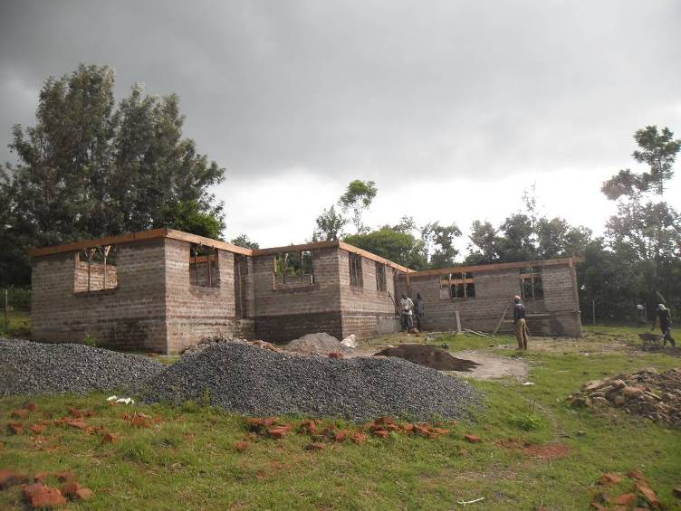 Photo 2: Is the same as bove but of different view that is, side view.

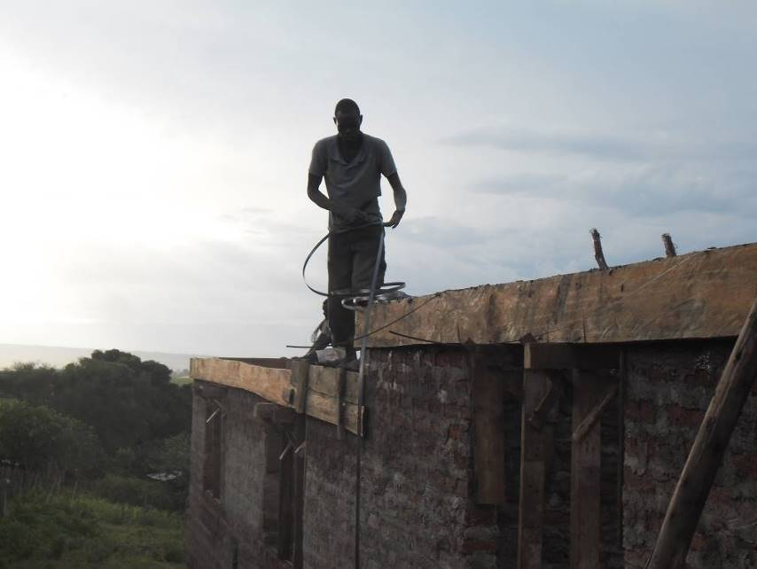 Photo 3: The mason is fixing the wallpass before pouring the concrete.
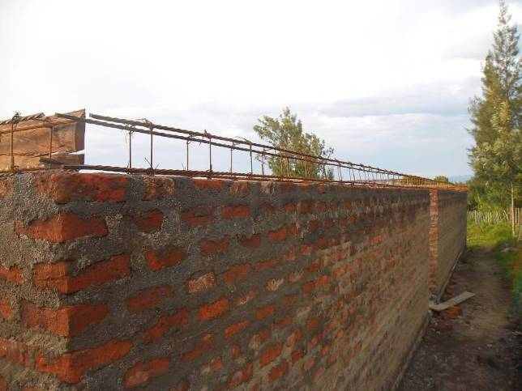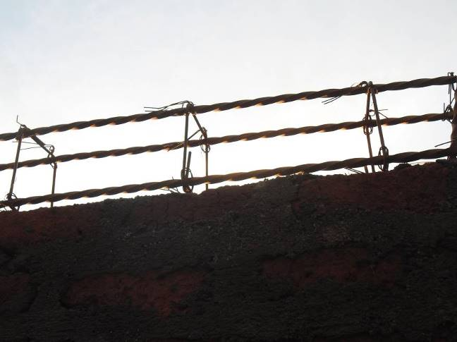 Photos 4: See the metal Y12 fixed on the wall before the concrete is poured on it to form the lintel/beam.

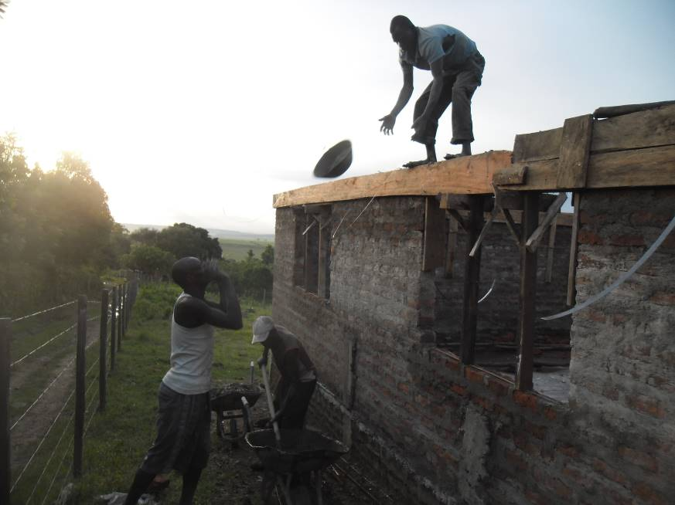 Photo 5: Men at work;pouring the concrete mixture to make the lintel/beam.
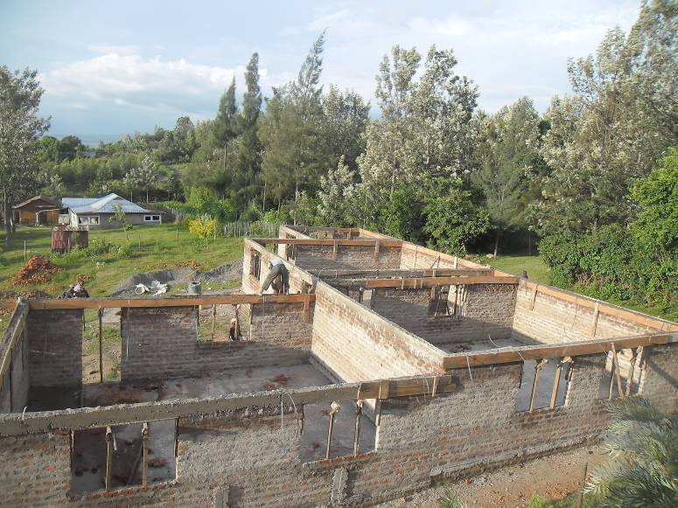 Photo 6: Showing the building with the lintel/beam.
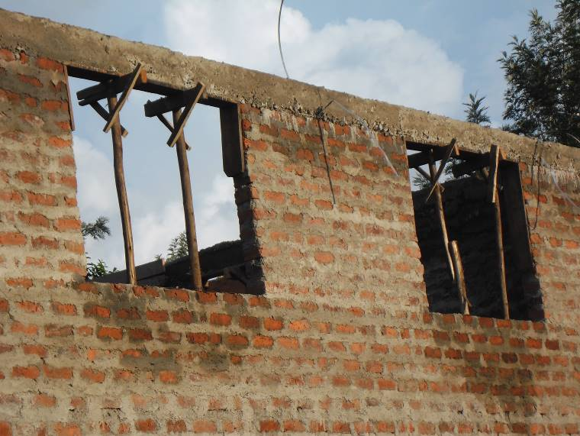 Photo 7: Showing the lintel/beam
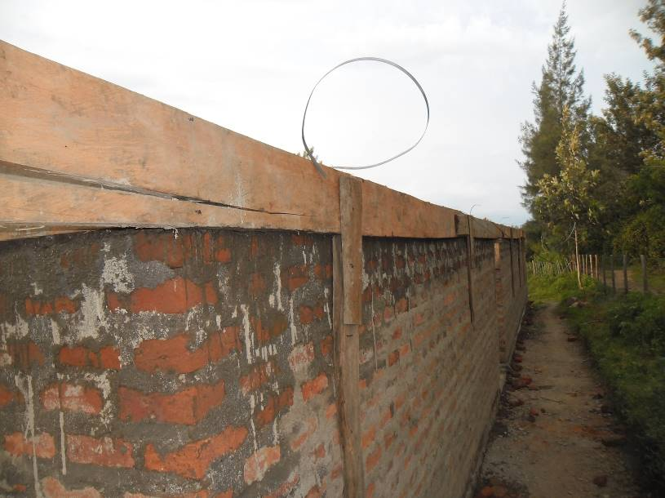 Photo 8: Showing the timber,9x1 during the construction of the lintel/beam.See the wallpass hunging. The wallpass has to protrude so as to help during the roofing.

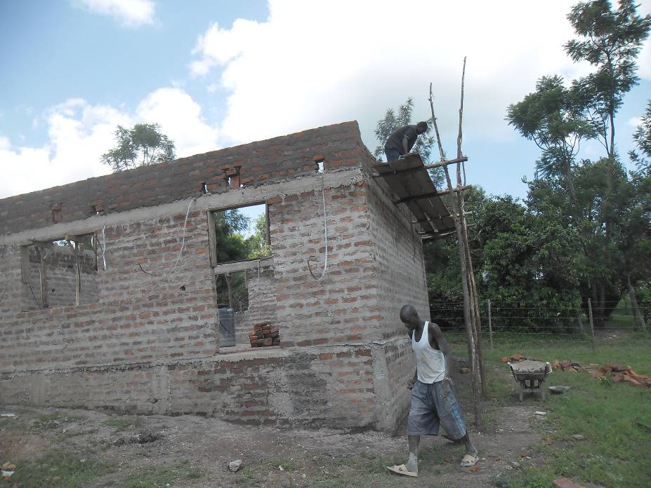The photos below show the wallplate being construtced.This is where we are now.The wallplate has to be constructed to the recommended height then the two triangles on both sides of the angles (ghebo) will be constructed after which roofing will be done.
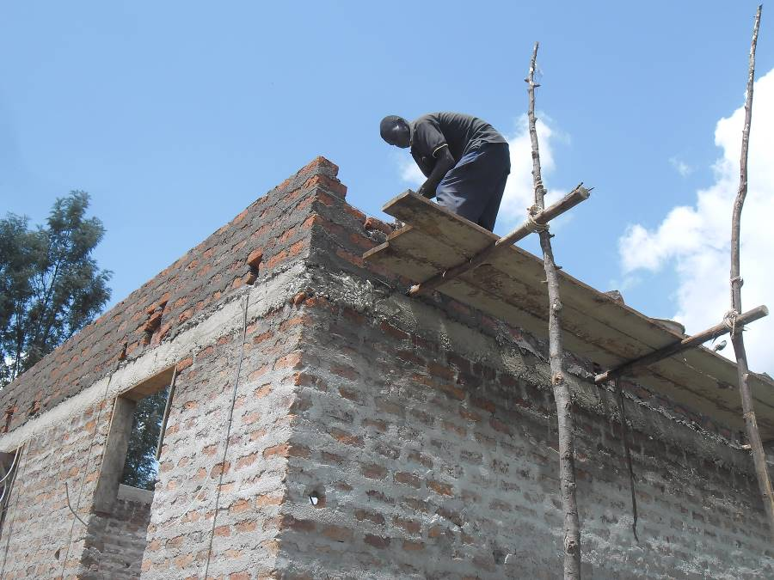 See the lintel/beam and on top of the lintel is the wallplate being constructed.
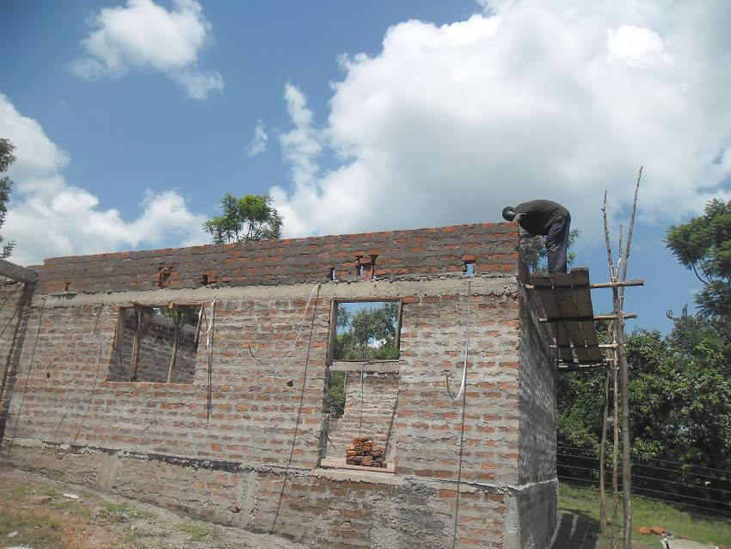
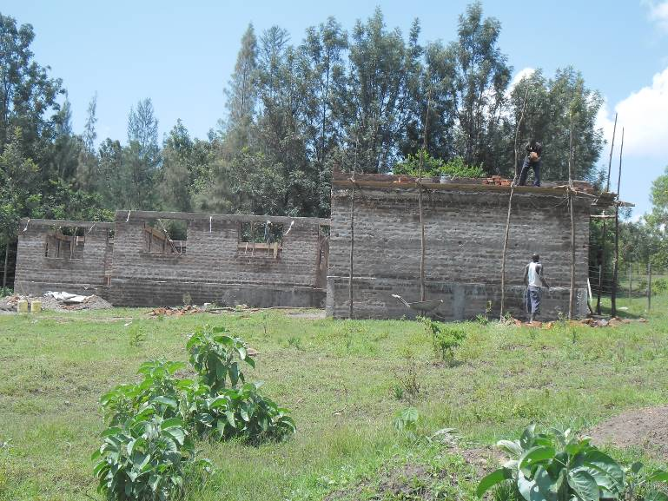 Wallplate being constructed.

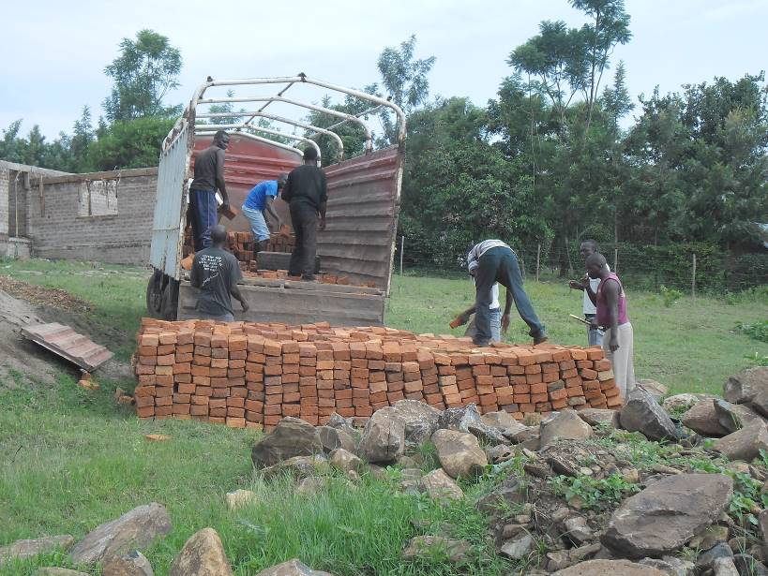 3,000 bricks purchased on 22/05/2016 for the continuation of the construction being offloaded in the project site.

This is for now, i’ll be back with more on roofing budget and other important part of this project.
So far,what do you say? Do you like the work?
Otherwise,thank you very much for the enormouse support,let us keep the spirit.
Tom Omondi Okoth
THE PROJECT COORDINATOR

