CONSTRUCTION OF
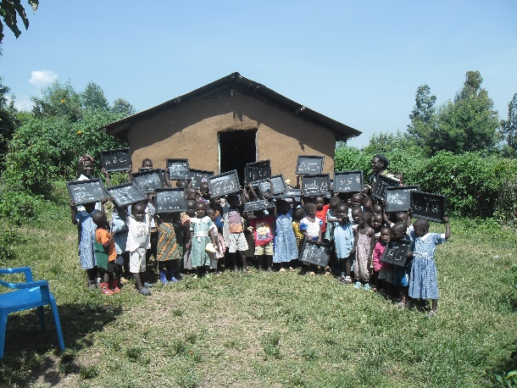
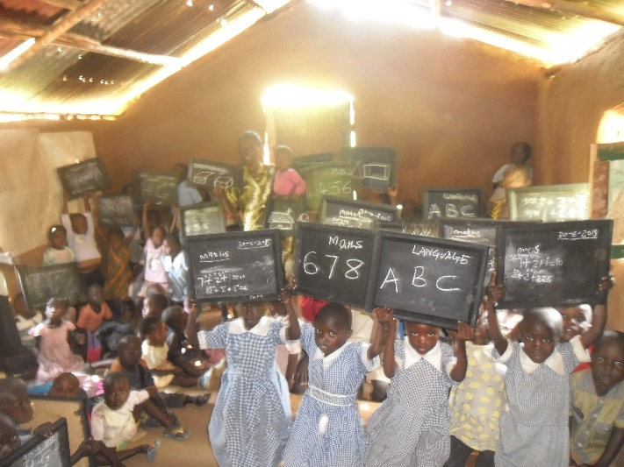
GRACE NURSERY SCHOOL

PROGRESS AND ECONOMIC REPORT

PHASE TWO OF THE PROJECT

JUNE 2016

Grace Nursery School Project Phase II
Submitted by Tom Omondi Okoth to ‘THE BIG FIVE’, Askoy Rotary Klubb and the rest of the sponsors in Norway on 4th June 2016.
- Project Profile
Project title: | Grace Nursery School
Project location: | Koguta village-Kericho County, Kenya
Project start date: | 20th February,2016  NB: Project started in February after receiving money from Eli Lexander.
End of phase two: | 31st May 2016
Received amount for phase two on 14th April 2016: | Ksh 542,822.65
Available balance as at April 2016: | Ksh 11,083.37
Actual balance as at April 2016 for phase two: | Ksh 553,906.02

- Background
Grace Nursery School is located in rural Kenya in the upper region of Koguta village in Kericho County. The school has a total of 86 pupils (35 in baby class, 32 in middle class and 19 in final class). When Terje, Eli, Helge, Kari and Froydis first visited the school in 2015, they were dumbfounded at what they saw. The children’s clothes were in tatters, their single classroom and other facilities were in disrepair, the roof was leaking and the mud-wall was almost crumbling, the floor was dusty and they weren’t receiving adequate nutrition. Despite this, the team from Norway saw the potential for the school to become a sustainable project that could have a positive impact on the wider community by purchasing a piece of land within the village and brainstorm on how to construct improved nursery school structure to uplift the education of rural Kenyan children. Therefore, this project aims to develop a conducive environment for learners in order to meet the needs of our dynamic society and accept the virtues of hard work and responsible behavior for a better future and country.
- PROJECT PROGRESS
3.1 Current Progress
Please receive the progress as at now and the activities that were done in the second quarter since the receipt of the money on 14th April, 2016 by the Local Project Coordinator, Mr.Tom Omondi Okoth from the Project Secretary and Treasurer, Eli Lexander. I extend my gratitude to “The Big Five”-Eli Lexander, Helge Skogstrand, Terje Engevik, Kari, Froydis and Askoy Rotary Club members who have continued to extend their support to uplift the education of rural Kenyan children and have mobilized funds towards this cause.
Progress to date [ -May 2016 ]
- Eli Lexander, Teje Engevik, Helge Skogstrand, Kari and Froydis paid a visit to the Grace Nursery School in June, 2015.
- Purchase of a piece of land after receiving fund from Helge Skogstrand for the construction of the Nursery School on 16th August 2015.
- Renovation of the Grace Nursery School roof after receiving funds from Terje and Kari on 5th September 2015.
- Fencing of purchased piece of land after receiving money from Helge Skogstrand on 22nd October 2015
- Purchase of building materials after receiving funds from Eli Lexander on 20th February 2016.
- Ground breaking and basic construction of the foundation started on 24th February 2016.
- Phase one ended on 5th April 2016
- Phase two-construction of the wall began on 17th April 2016
- Phase two-construction of the wall up to the recommended height ended on 31st May 2016
During the period of mid April 2016 to late May 2016, a lot happened at the nursery school project site as highlighted below:

- Bricks
A total of 7,000 bricks were purchased and ferried to the construction site by a lorry.
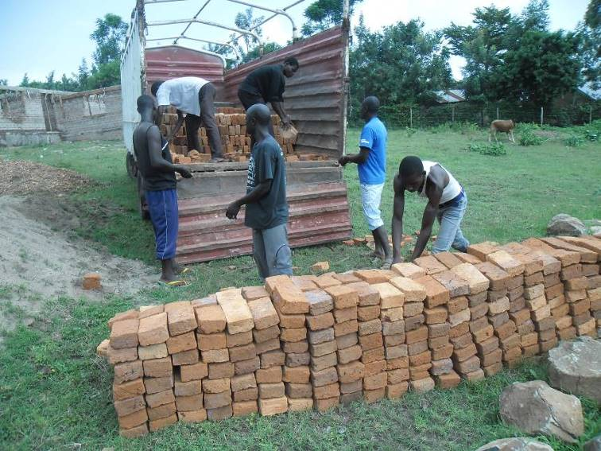 Photo 1: Men offloading the bricks from the lorry in the construction site.
- Lake sand
Lake sand was purchased within the shores of Lake Victoria and ferried to the construction site. Due to the heavy rainfall in the month of April to May, sand harvesting area was waterlogged and muddy and for that reason a lot of difficulties were experienced leading to much time taken within the sand region hence reaching the construction site late in the evening. You can see the photo below was at night.
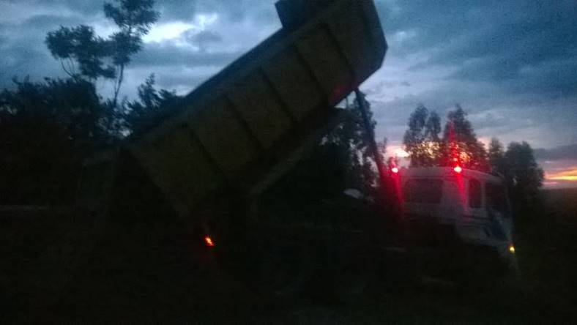 Photo 2: Lorry offloading lake sand.
- ECONOMIC/ FINANCIAL REPORT
After constructing the foundation to completion, the project had available balance in the account Ksh 11,083.37 then Eli Lexander transferred extra money;14th/04/2016 RTGS/RMT AS C Ksh 542,822.65. Therefore, the actual balance in the project account for phase two was Ksh 553,906.02 respectively.
  - Economic expenditure and itemization
A total of Ksh 484,605.00 was spent enabling phase two of the project be completed magnificently leaving effective balance of Ksh 66,100.06 in the project account as highlighted below:
HARDWARE MATERIALS | QUANTITY PURCHASED | UNIT COST (KSH) | TOTAL COST (KSH)
Bags of Cement | 98 | 750.00 | 73,500
Transportation of cement | 98 | - | 7,500
Metals Y12 | 57 | 930.00 | 53,010
Metals R6 | 28 | 250.00 | 7,000
Transportation of metals | 85 pieces | 3,000 | 3,000
Lake sand | 2 Lorries | 25,000 | 50,000
Timber 9x1 | 387fts | 95.00 | 36,765
Timber 6x1 | 256fts | 30.00 | 7,680
Transportation of timber | 643fts | - | 4,000
Dump Proof Cost (DPC) | 3 rolls | 3,000 | 9,000
Eucalyptus poles | 35 pieces | 200.00 | 7,000
Wall pass | 3 rolls | 2,700 | 8,100
Wire nails 1,3 and 4 inches | 24 kgs | 200.00 | 4,800
Binding wire | 4 rolls | 2,600 | 10,400
Bricks | 7,000 | 11.50 plus transport | 80,500
Metallic trays/trough | 4 | 500.00 | 2,000
Wheelbarrows | 2 | 3,200 | 6,400
Metallic spades | 3 | 500.00 | 1,500
Mattocks | 2 | 600.00 | 1,200
Water use and cost | - | 16,250 | 16,250
MASON LABOUR CHARGE | FOR | PHASE | TWO
TOTAL CHARGES FOR WALL CONSTRUCTION |  |  | 95,000
TOTAL EXPENDITURE |  |  | 484,605.00
TOTAL BANK CHARGES |  |  | 3,200.96
EFFECTIVE BALANCE |  |  | 66,100.06
*Materials purchased from Shree Ganesh Hardware, Dajama Hardware, Comacon Ltd, Soin Ranch Ltd and Nyabondo bricks and Construction Ltd*

  - Challenges faced
- Due to the heavy rainfall in the month of April to May, sand harvesting area was waterlogged and muddy and for that reason a lot of difficulties were experienced leading to much time taken within the sand region hence reaching the construction site late in the evening.
- The heavy rain lead to the collapse of Muhoroni Bridge; the main link between Koguta village and Muhoroni town thus hampering transportation services and eventually leading to an increase in the cost of materials and transportation cost (photos below).
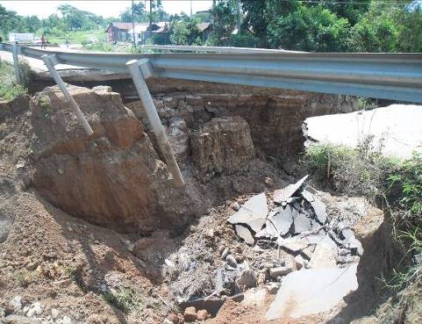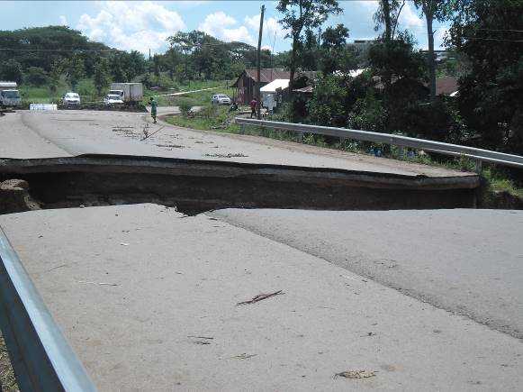
Photos 3: Collapsed Bridge; the link between Muhoroni and Koguta village.

  - Conclusion
Appreciation is extended to THE BIG FIVE (Eli Lexander, Helge Skogstrand, Terje Engevik, Froydis and Kari) who visited Koguta village in Kenya and brainstormed on constructing a better Grace Nursery School. Thank you very much for your commitment on this project. Much thanks to Askoy Rotary Club members and all friends in Norway for their continuous support on our projects.
Please may you continue supporting the project to enable Koguta village children have a conducive learning environment for a better future and ones again, i promise that 100% of your donation will be utilized for the purpose it was meant for.
Thanking you sincerely.

- PICTURES AND ELABORATIONS

  - Pictorial Data
  - 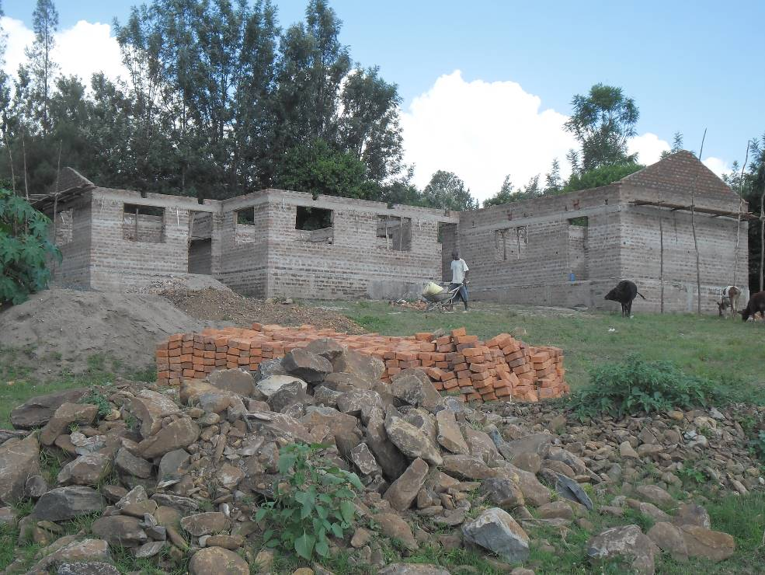
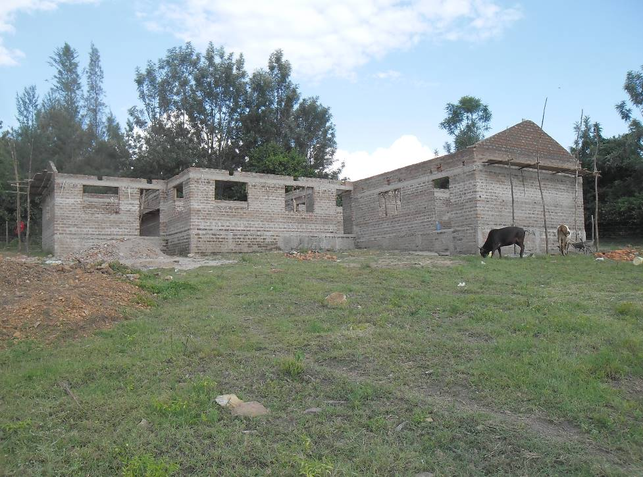Photos 1: Front view of the building. You can see cows visiting the compound.
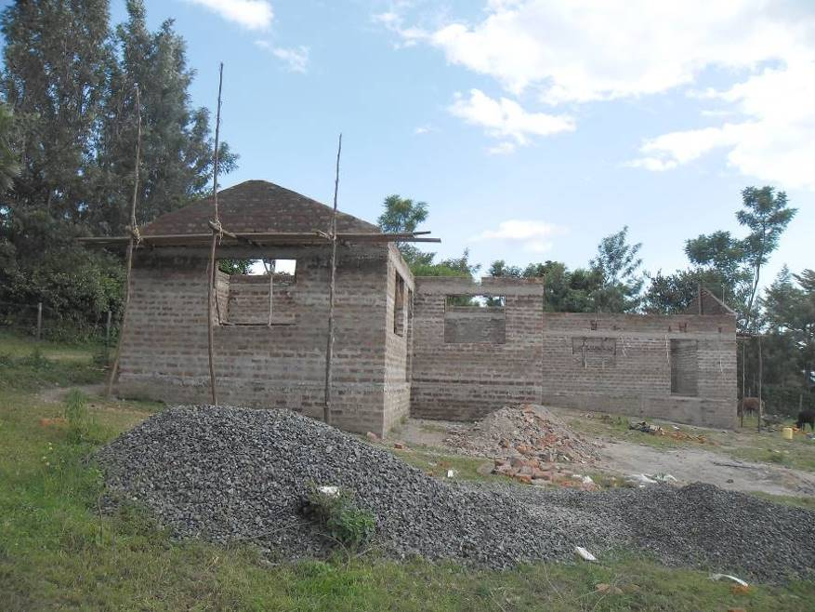 Photo 2: Side view of the building.
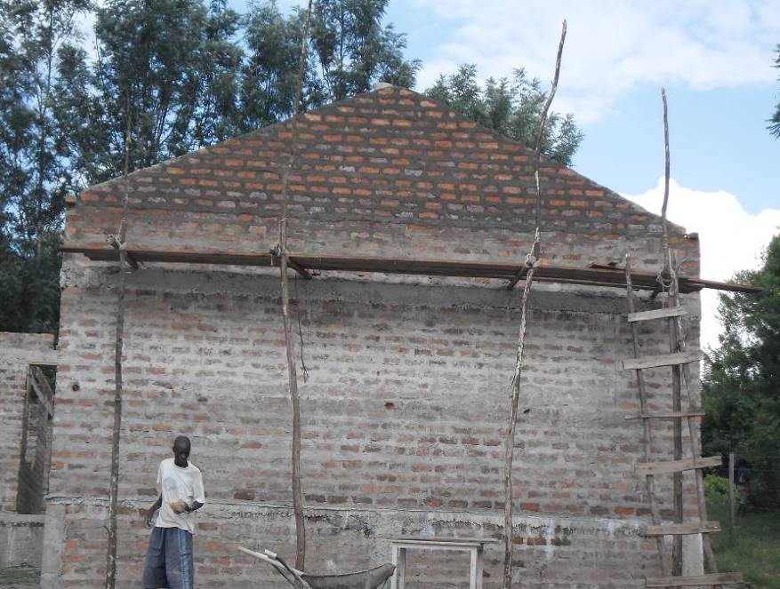Photo 3: Front Gabo-part of the structure.
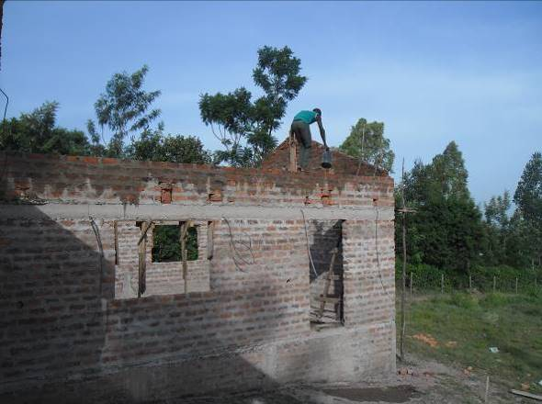 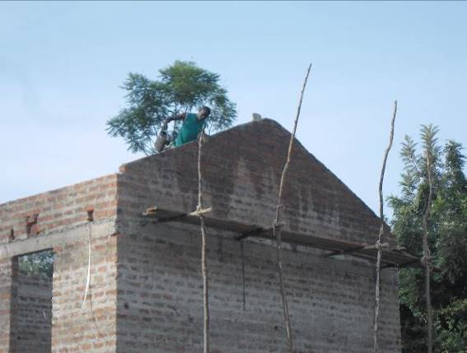 Photos 4: Curing is being done; this is one area where water is used a lot.
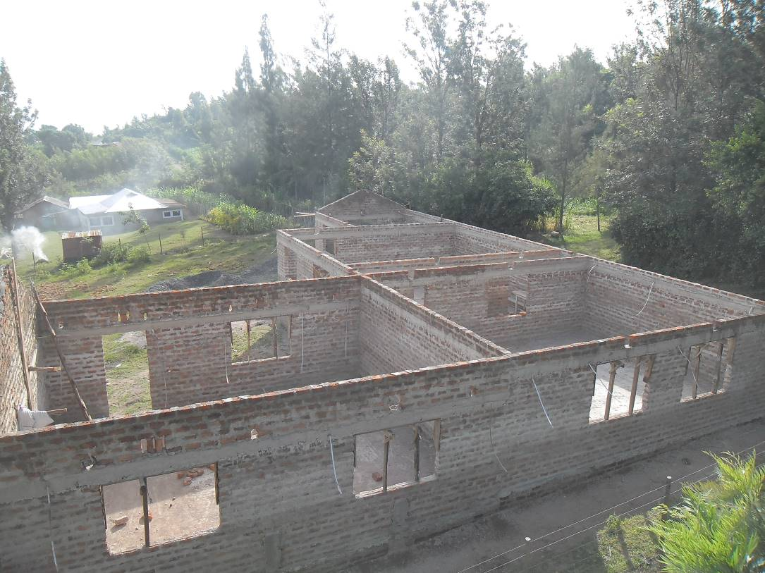 Photo 5: Aerial view of the building.

  - Name and email address of person [s] to contact for clarifications:
Name: Tom Omondi Okoth : Eli Lexander
Position: Project Coordinator : Secretary/Treasurer
E-mail: tomsomondi@yahoo.com : elex@online.no
Mob. +254-700 175 173 : +47-91 33 13 92

Prepared and written by Tom Omondi Okoth on 3rd June, 2016

